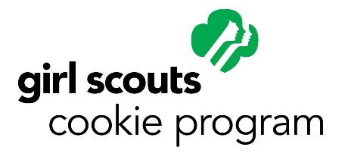

TO: MANAGER

FROM: Stacie Stolba

DATE: 8/5/2018

RE: Cookie Booth Sale – 2018

Girl Scout Service Unit #659 requests permission to set-up their annual Cookie Booth Sale in front of your establishment on the below listed dates and times.

All Girl Scout Service Units are restricted to their own individual territories. Should another Girl Scout group or person approach you requesting permission to sell, I would appreciate a call so that I can address and resolve the conflict/confusion.

Thank-you for your patronage and we look forward to working with you!

Stacie Stolba
Cookie Booth Sale Coordinator, SU #659
Cell: 410-419-7580

Howard County Library – 2350 State Road 97, Glenwood Branch
Monday – Nov 19th 2pm – 6pm
Tuesday – Nov 20th 2pm – 6pm
Wednesday – Nov 21st 10am – 2pm / 2pm – 6pm
Sat – Oct 20, 27, Nov 3, 10, 17, 24, Dec 1, 8 10am – 2pm / 2pm – 6pm
Sun – Oct 21, 28, Nov 5, 11, 18, 25, Dec 2, 9 1pm – 5pm

Approved By: Date:

