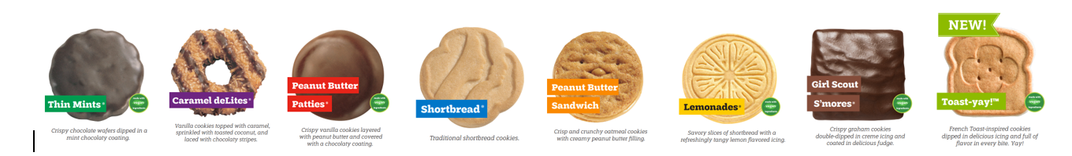
?????? is so excited to sell cookies again this year.
Last year she sold ??????boxes of cookies!

Can you help her reach her goal of ?????? boxes this year?

Cost is $5.00 per box.
The cookies will be available starting November 10th, so pre-order them now.
You can also buy boxes to donate to our "Cookie Share" which supports our Hometown Heroes and the Military. We hand them out to our Military, Teachers, Fireman, and Police. The Girl Scouts also send them overseas to the Military.
The Girls love handing them out and thank our heroes for their service.
The cookies are listed below with a description.

Look for an email from ?????? thru noreply@abcsmartcookies.com where you can make your order online and ?????? will be calling and confirming your orders. There are two options, Girl Delivery (where ?????? will make arrangements to deliver the cookies to you) and Direct Ship (cookies will be shipped directly to your destination for a small shipping fee. Both options will allow for you to pay with credit card ahead of time.
Thank you very much for your support,
??????
Troop ??????
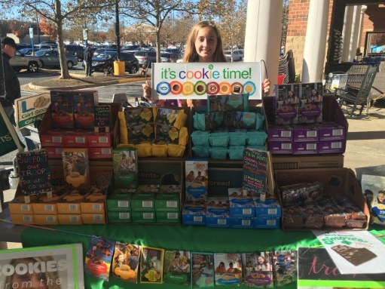
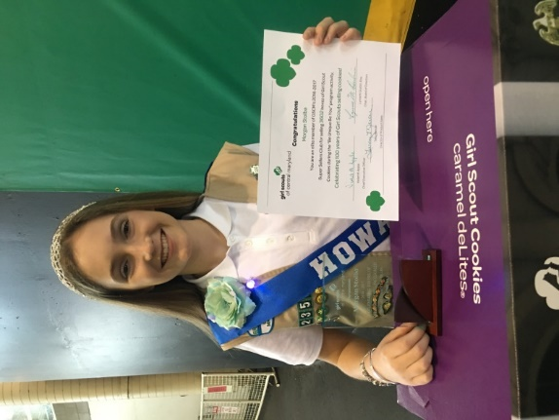
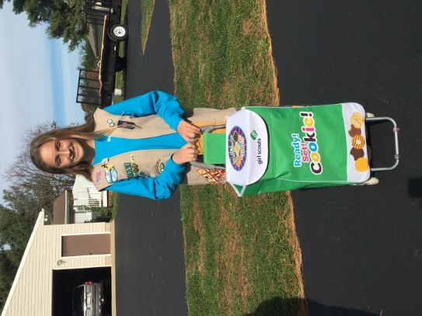

Cookie price: $5.00 per box and $6 a bag for our Gluten Free Caramel Chocolate Chip cookies.

Delivery will be after November 10th.

